Toll System using Automatic Number Plate Detection

In this project users can create account with vehicle number and then add balance to wallet and whenever user visit any toll booth then admin will upload image of user vehicle and then application will automatically detect number plate and then deduct balance from his wallet and if wallet balance or account does not exist then alert error will be thrown.

To upload images we are using below vehicles

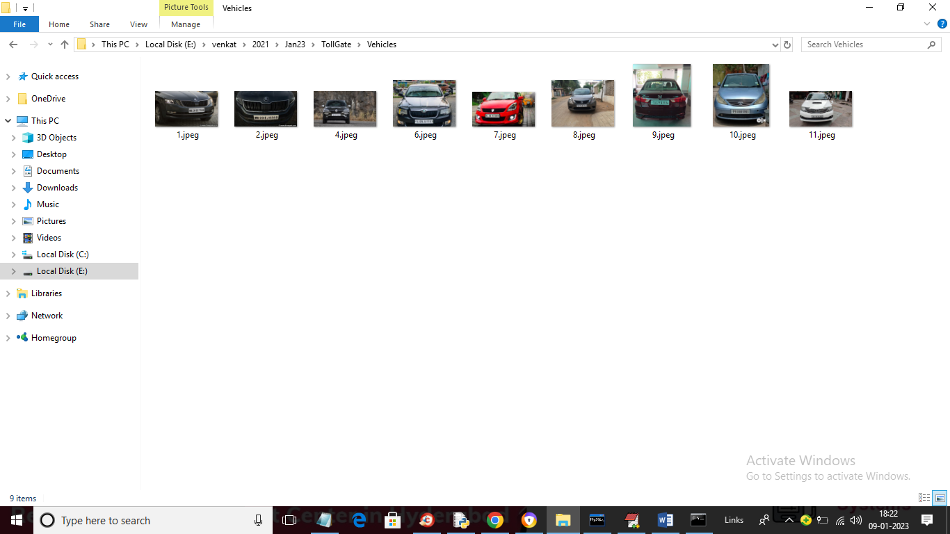

This project consists of two users

1. Toll Booth Admin: can login to system using username and password as ‘admin’ and then upload vehicle image to collect payments and can view payments also
2. User: user can signup and create a wallet with vehicle details and balance amount and whenever he visit toll both then admin will upload image and collect payment.

To run project create database by copying content from ‘DB.txt’ file and paste in MYSQL and then double click on ‘run.bat’ to start web server and get below page

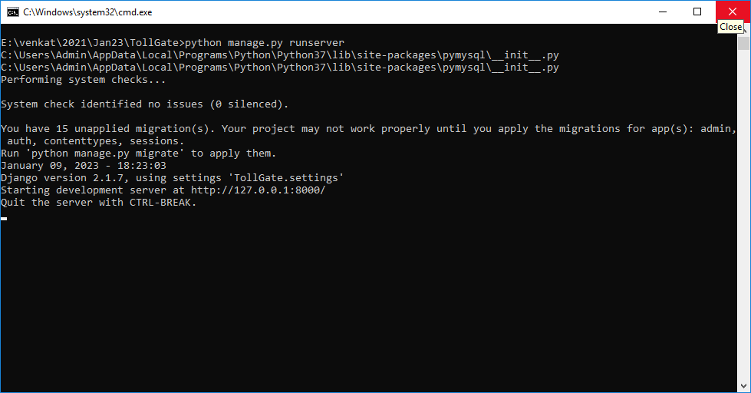

In above screen web server started and now open browser and enter URL as ‘http://127.0.0.1:8000/index.html’ and press enter key to get below page

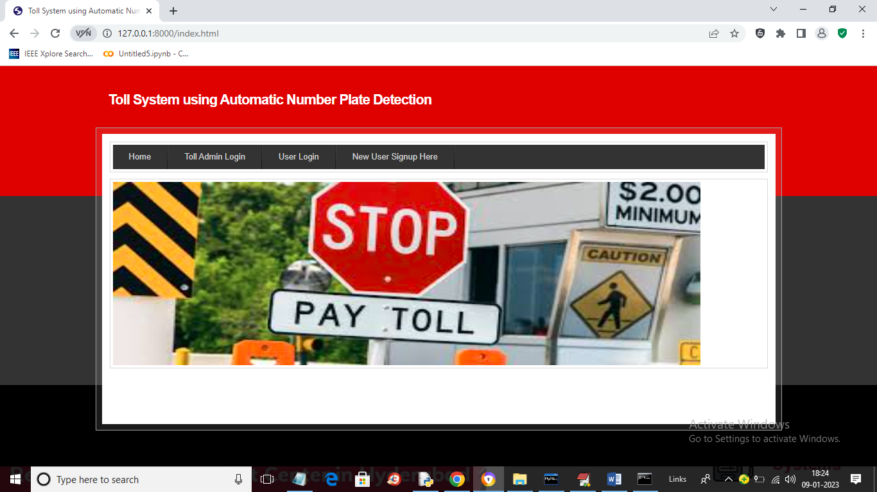

In above screen click on ‘New User Signup Here’ link to add new user like below screen

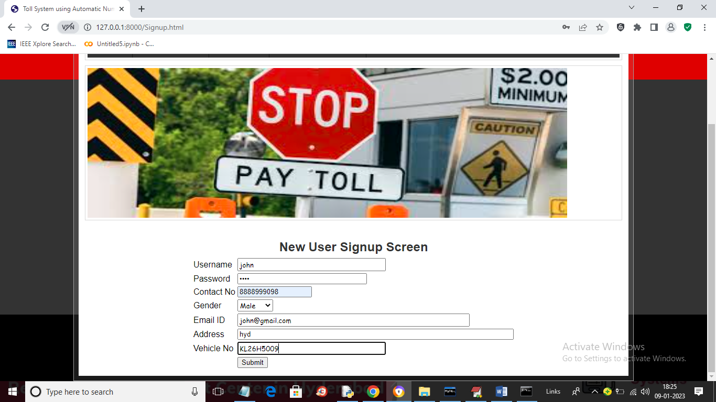

In above screen user is signing up and entering vehicle no and then press button to get below output

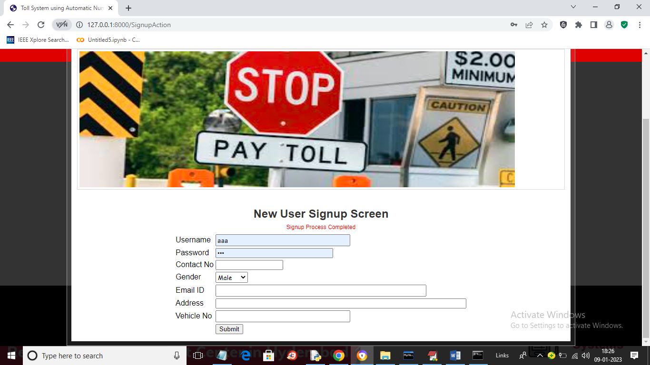

In above screen signup process completed and now click on ‘User Login’ to login as user

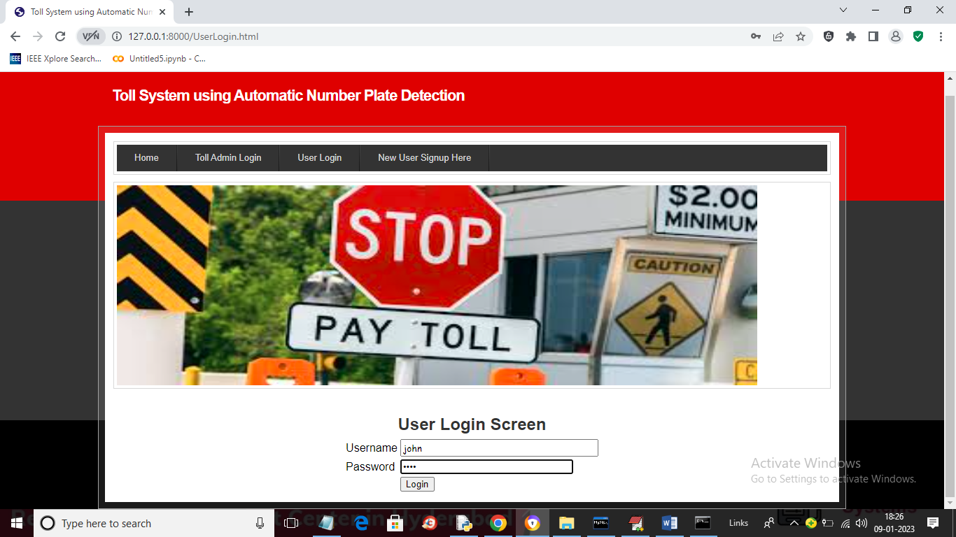

In above screen user is login and after login will get below page

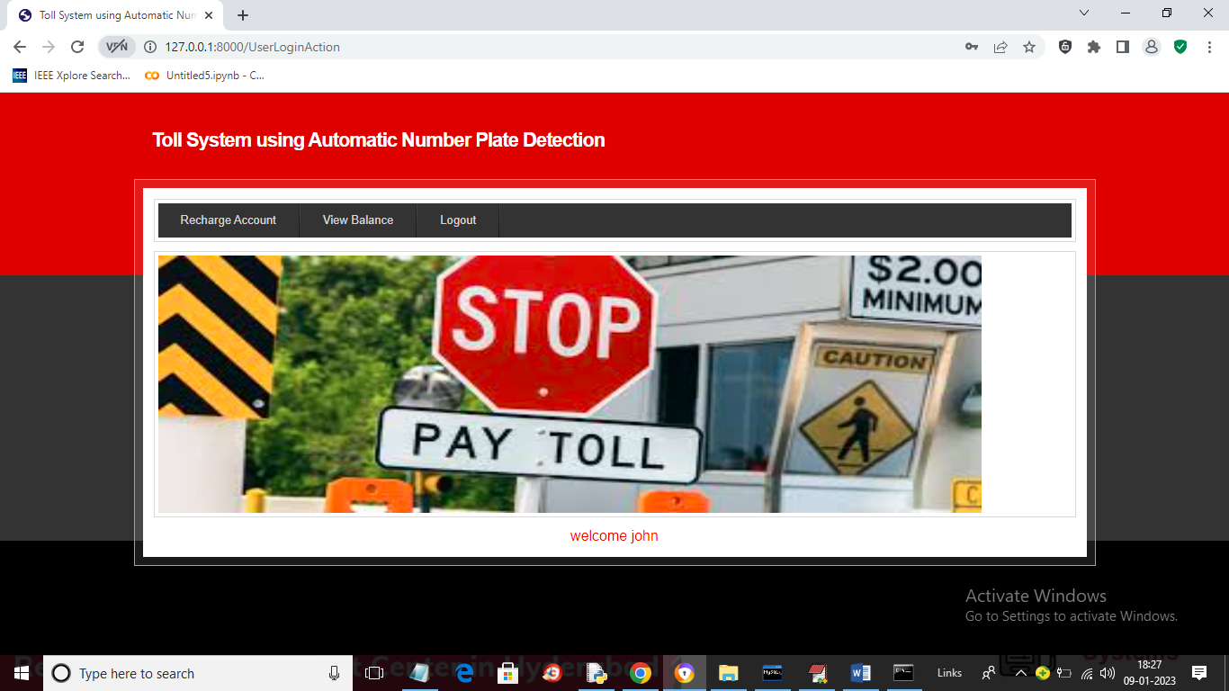

In above screen user can click on ‘Recharge Account’ link to add amount to wallet and get below output

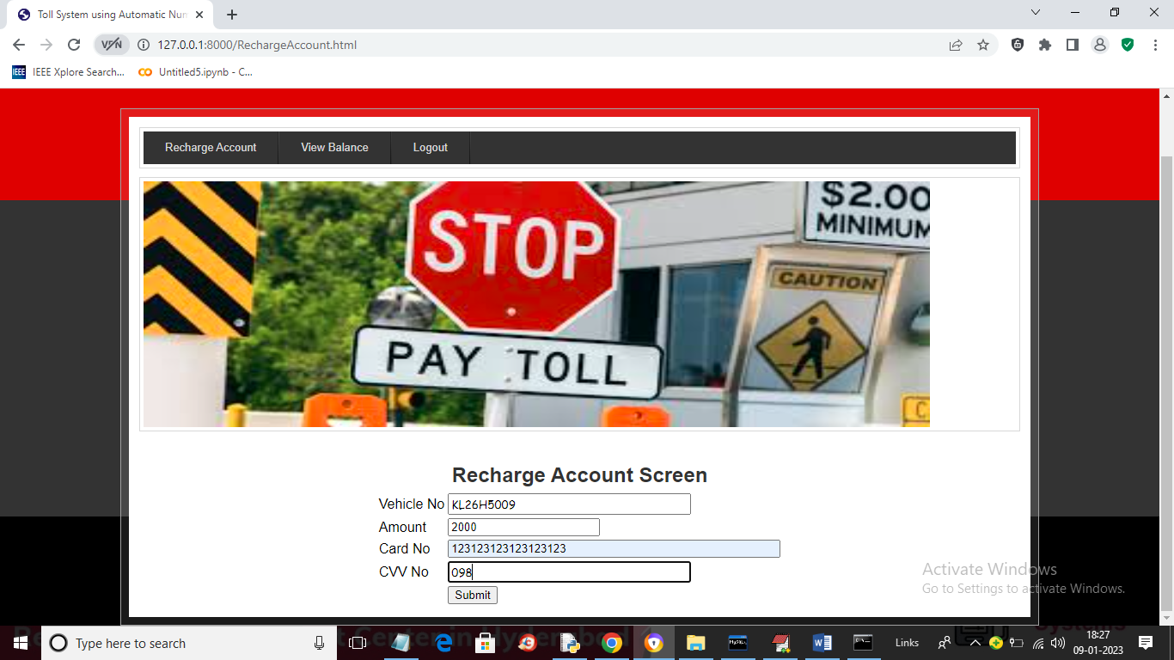

In above screen user will enter his bank card details and then press button to add amount to wallet and get below output

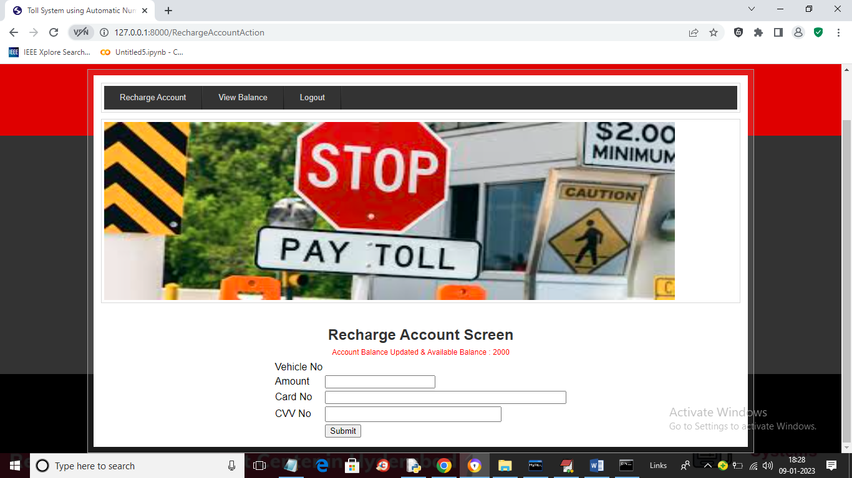

In above screen wallet is updated with 2000 and now click on ‘View Balance’ link to get below page

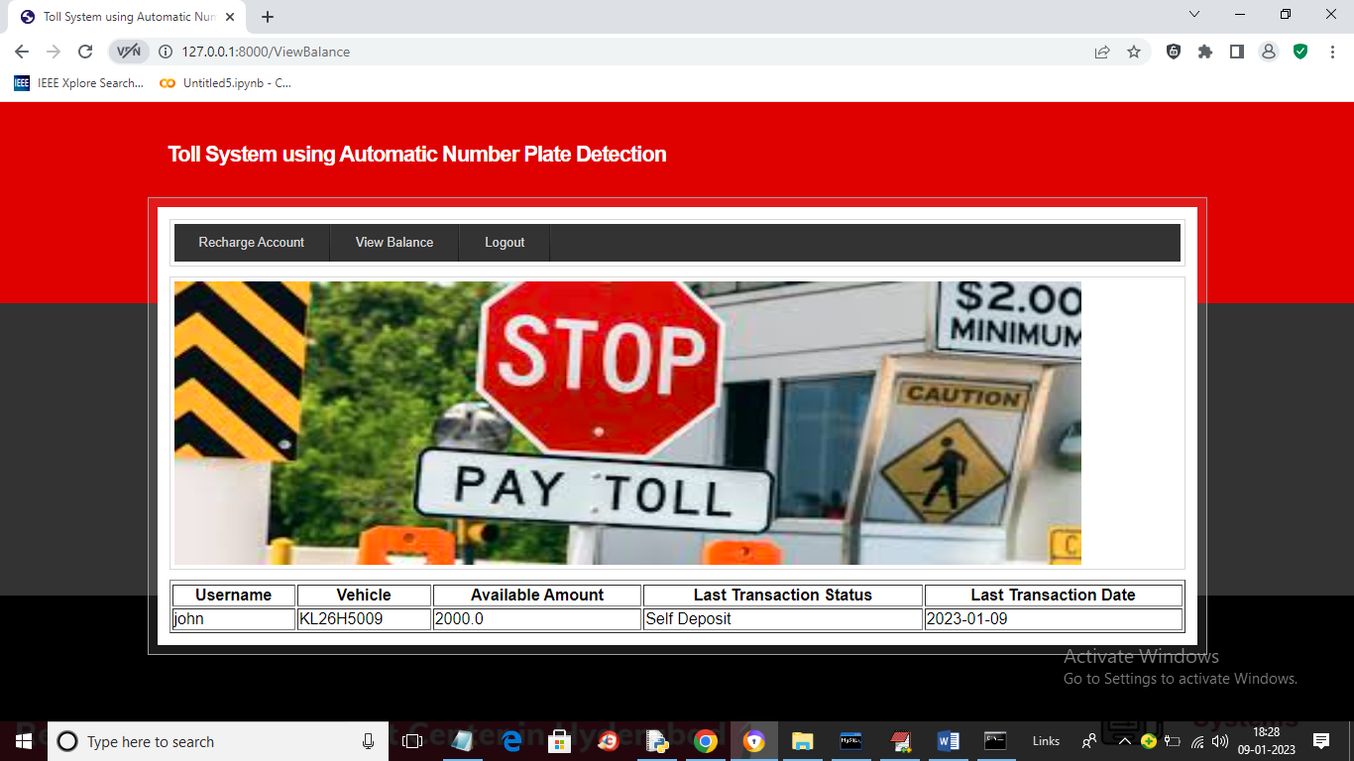

In above screen user can view his wallet balance and now logout and login as toll booth admin to upload image and deduct amount

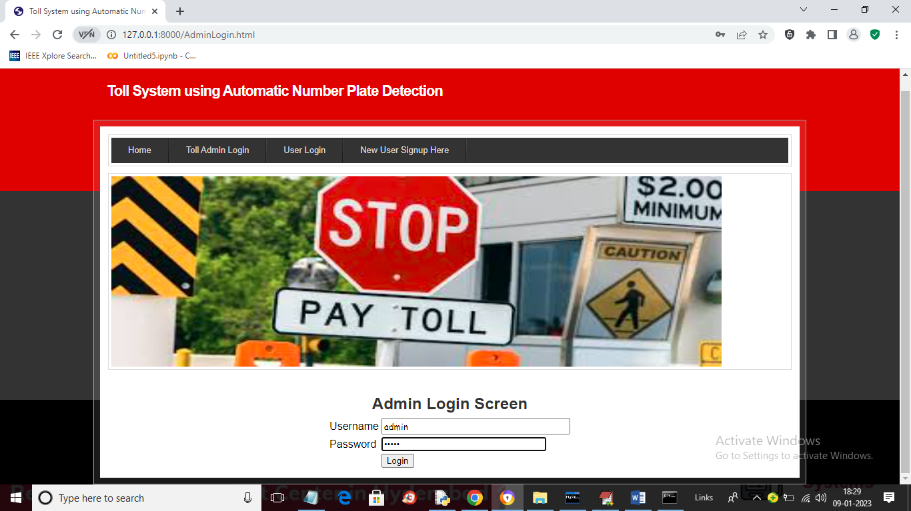

In above screen admin is login and after login will get below page

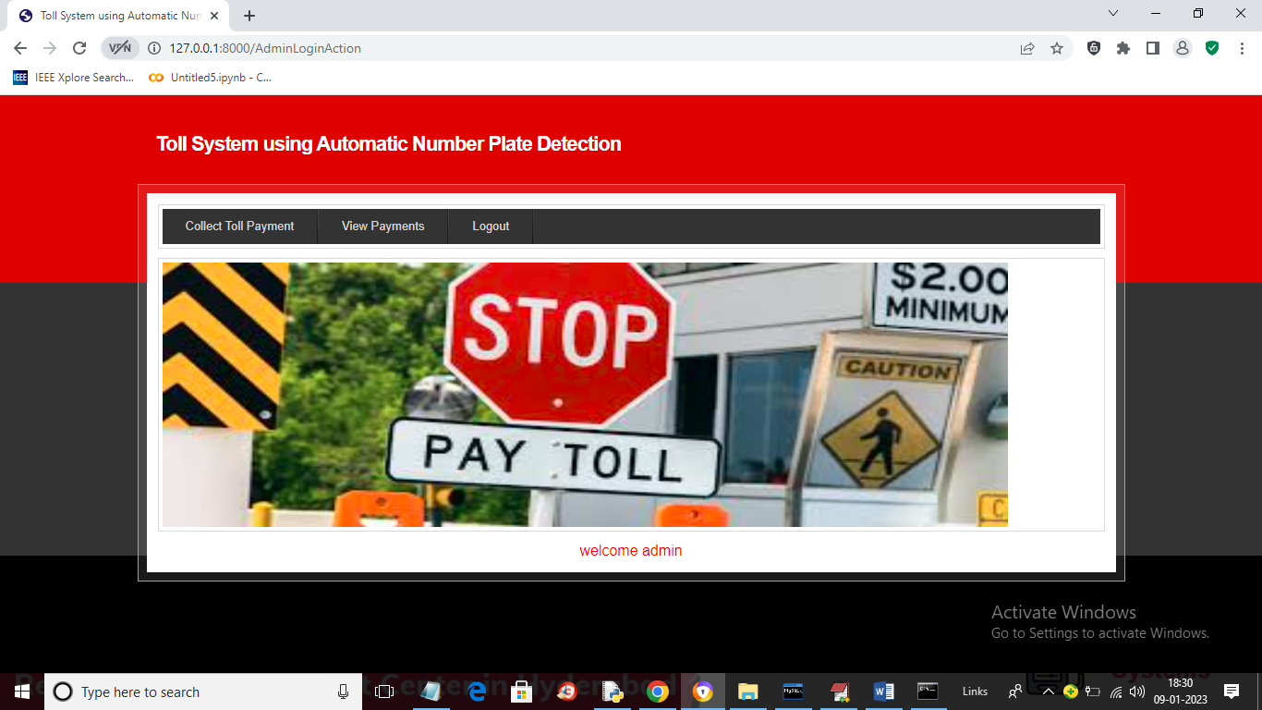

In above screen admin will click on ‘Collect Toll Payment’ link to get below page

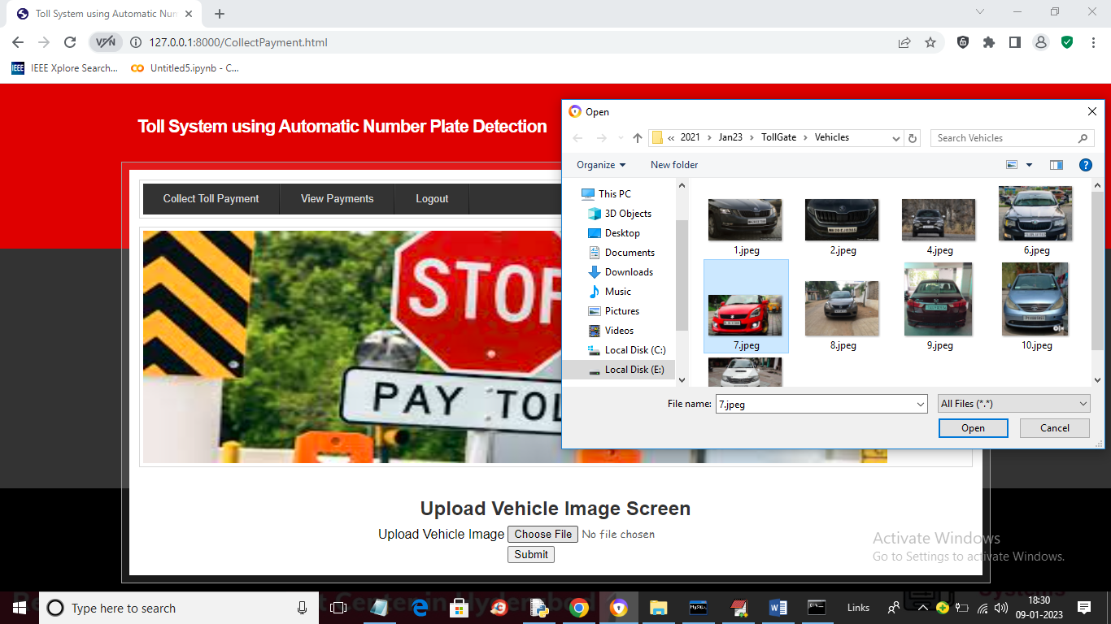

In above screen admin is uploading vehicle with same number plate from which user registered and then click on ‘Open’ and ‘Submit’ button to get below output

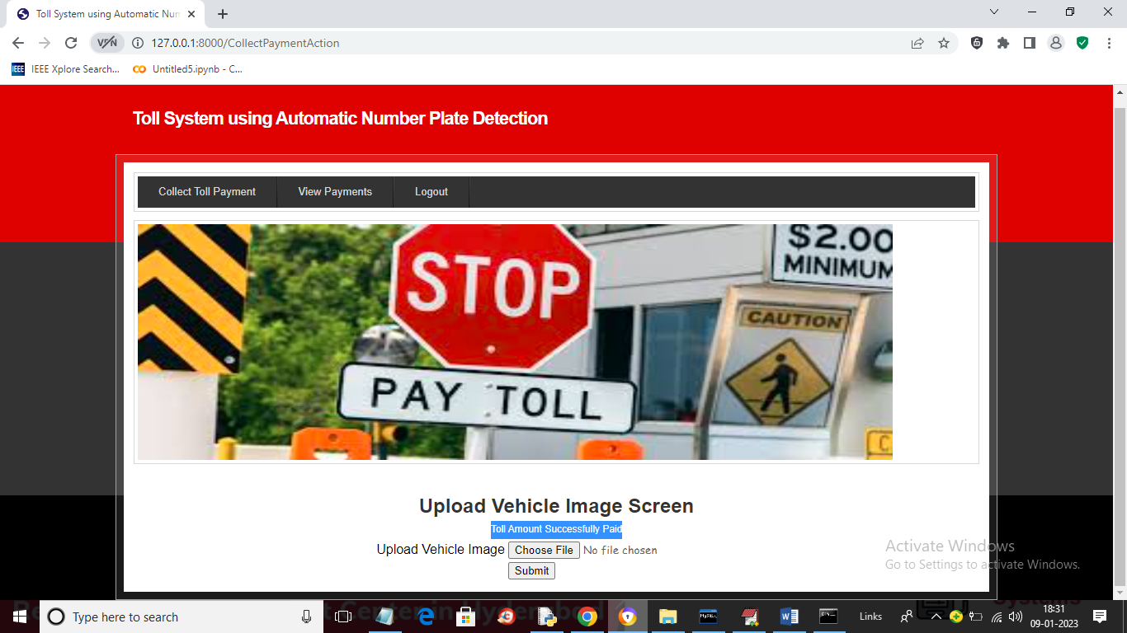

In above screen in blue colour text we can see ‘Toll Amount successfully paid’ and this transaction admin can view by clicking on ‘View Payments’ link to get below page

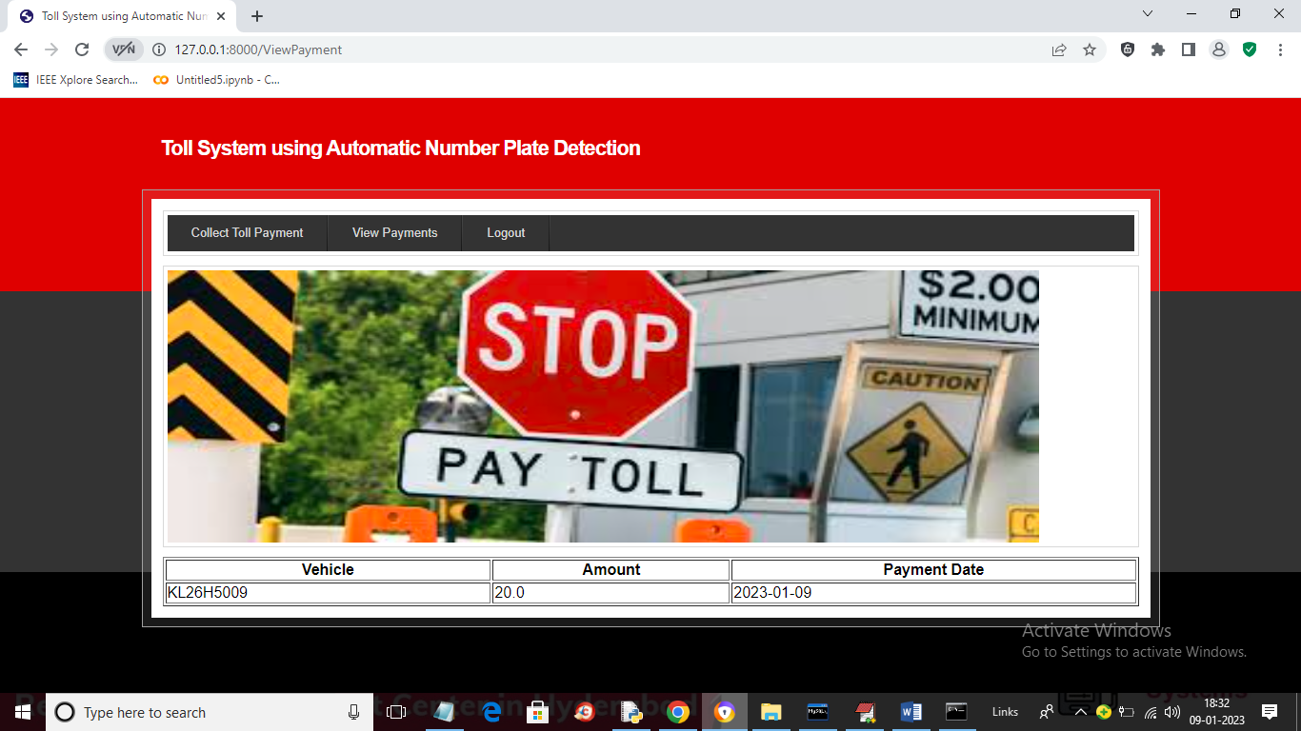

In above screen admin can view extracted vehicle number and deducted amount with date.

Similarly you can create wallet and admin can upload image and deduct wallet amount. If we upload other image then will get below output

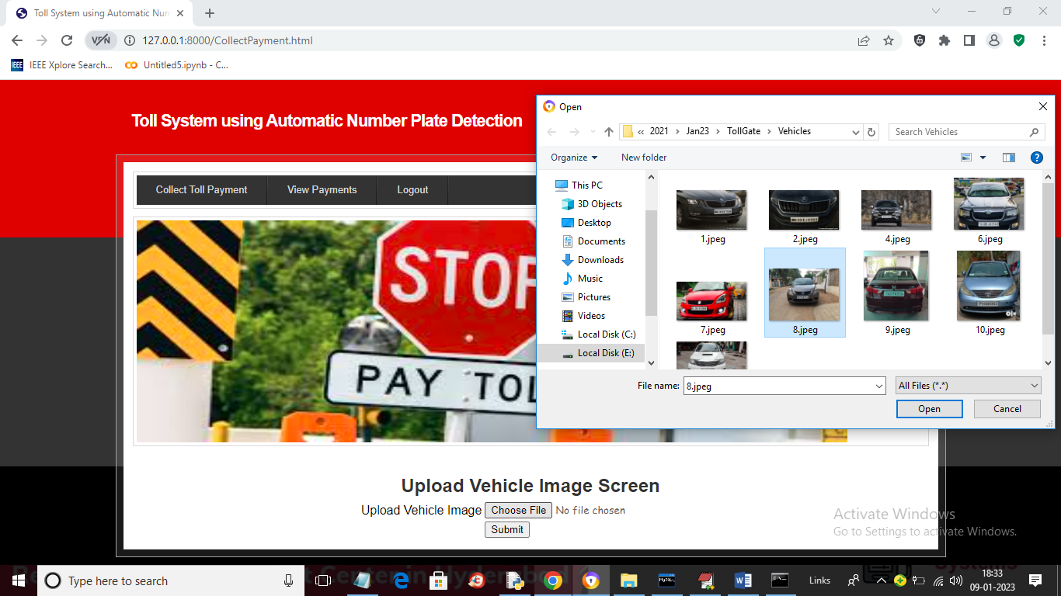

In above screen uploading unregistered vehicle image and below is the output

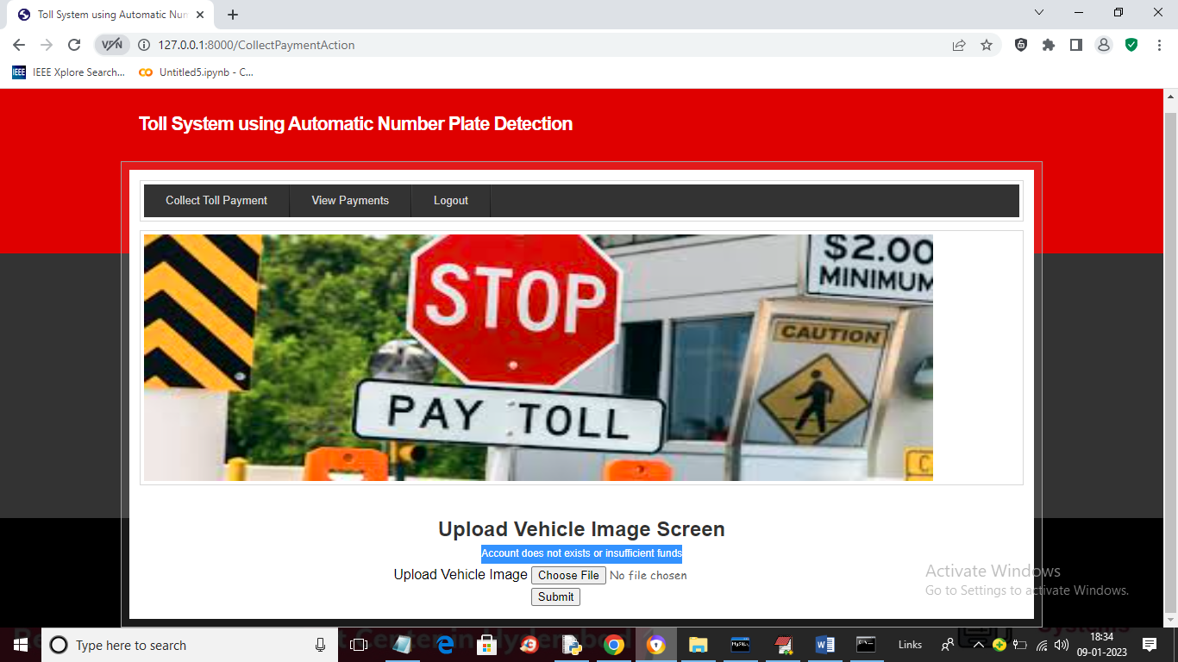

In above screen in blue colour text we can see account does not exists